COCA-COLA
Project By,
NIKET SHAH
VYSHNAVI MEDIKONDA
PURVI MEHTA
SMIT DAYANI

PROFESSOR YANRU HAN
11/25/2024

The Coca-Cola Company is most recognized for its trademark soft drink, Coca-Cola. John Stith Pemberton established it in Atlanta, Georgia, in 1886, and it has since expanded into a global company with a wide range of products. In addition to the Coca-Cola brand, Coca-Cola also sells beverages under the Sprite, Fanta, Minute Maid, Dasani, and Powerade brands. The business uses a global network of distributors and bottlers to run its operations.
Here’s a table summarizing the key information about selected bonds issued by The Coca-Cola Company based on publicly available data:

COUPON RATE | MATURITY DATE | COUPON TYPE | COUPON PAYMENT DATE | CALLABLE
5.45% | June 1,2034 | FIXED | SEMI-ANNUAL (JUNE 01 AND DECEMBER 01) | YES
5% | May 13, 2034 | FIXED | SEMI-ANNUAL (MAY 13 AND NOVEMBER 13) | YES
3.45% | March 25,2030 | FIXED | SEMI-ANNUAL (MARCH 25 AND SEPTEMBER 25) | NO
4.2% | MARCH 25,2050 | FIXED | SEMI-ANNUAL (MARCH 25 AND SEPTEMBER 25) | NO

The bonds are callable before maturity at a premium based on market conditions and a Treasury rate spread. Funds will be used for general corporate purposes like working capital, acquisitions, or refinancing existing debt.
Beta (5 years) is 0.62
PE ratio (TTM) is 26.52
EPS is 2.41
Source (Yahoo Finance)
Operating Environment, Size, Market Share, and Asset Value:
Coca-Cola competes with rival beverage behemoths like PepsiCo, Nestlé, and Red Bull in the cutthroat and quickly changing global beverage market. With operations in more than 200 nations, the business is a major force with a wide global presence.
Market Share: In the worldwide non-alcoholic beverage sector, Coca-Cola has a sizable market share, especially in the carbonated soft drink (CSD) sector. According to brand valuation firms, its brand is still among the most valuable in the world. Market Cap of coca cola is 275.355B
Size: Including its bottling partners, the corporation employs approximately 700,000 people worldwide. With a market valuation that often places it among the top worldwide corporations, Coca-Cola generated about $46 billion in revenue in 2023.
Coca-Cola's assets: They are worth more than $90 billion, and a large amount of that value is attributed to its strong brand, manufacturing plants, and wide international distribution network.
Relevance to the Sector:
Because of its well-known brand, extensive global reach, and longstanding market dominance, Coca-Cola is among the most important businesses in the beverage sector. It has a significant impact on industry developments, especially those related to distribution networks, product development, and marketing. The company's extensive portfolio enables it to serve a wide spectrum of customers and adjust to shifting consumer preferences and health trends.
Brand Value: Among the most well-known and valuable brands in the world is Coca-Cola. Thanks to decades of effective marketing campaigns and a dependable brand identity, it has managed to hold onto this position.
Leadership in Sustainability: Coca-Cola is also at the forefront of sustainability efforts, aiming to cut down on water use, carbon emissions, and the development of environmentally friendly packaging.
Key Challenges and Opportunities
Coca-Cola's future will be shaped by a number of significant possibilities and challenges.
Health and Wellness Trends: Coca-Cola has been concentrating on low-sugar, sugar-free, and non-carbonated products such bottled water, teas, and energy drinks as a result of consumers' growing desire for healthier beverages. This trend offers Coca-Cola a chance to innovate in the wellness sector as well as a challenge.
Global Market Diversification and Expansion: Coca-Cola keeps growing its market share in developing nations, especially in Asia and Africa. Opportunities for growth are presented by this, but local tastes and preferences must also be accommodated.
Sustainability of the Environment: Carbon emissions and plastic waste are major environmental issues. To lessen its environmental impact, Coca-Cola is making significant investments in water conservation and environmentally friendly packaging. Its "World Without Waste" campaign, which aims to recycle one bottle for each one it sells, is a component of a larger attempt to increase sustainability.
E-commerce and Digital Transformation: As more people shop online, Coca-Cola must modify its distribution networks to support direct-to-consumer and e-commerce business models. E-commerce will open up new avenues for sales growth, particularly in light of post-pandemic changes in consumer behaviour.
Coca-Cola is a major force in the beverage sector thanks to its wide range of products, global presence, and great brand equity. The corporation has many prospects in growing countries, sustainability, and product diversification, but it also confronts problems from changing health trends and environmental concerns. The company's sustained emphasis on sustainability and innovation will be essential to preserving its position as the industry leader.
Coca-Cola's Market Position (2024)
Coca-Cola is a global leader in the non-alcoholic beverage industry, leveraging its unparalleled brand recognition, diversified product portfolio, and expansive market reach.
Sales and Market Share
- Annual Revenue: Coca-Cola reported $44.4 billion in net operating revenue for 2023, driven by strong organic growth of 9%​.
- Global Market Share: Coca-Cola holds a significant portion of the $1.5 trillion non-alcoholic beverage industry, commanding an estimated 50% of the global carbonated soft drink (CSD) market and approximately 3% of the total beverage industry​.
- Industry Position: Its dominance in the CSD segment positions Coca-Cola as the market leader, with competitors like PepsiCo trailing in market concentration.
- Geographic Revenue Mix: 37% from North America, 18% from Europe, Middle East & Africa, 15% from Latin America, 14% from Asia-Pacific, and the rest from global ventures​.
- Portfolio Strength: Coca-Cola owns over 500 brands across categories like carbonated drinks, bottled water, juices, and ready-to-drink teas/coffees. Product lines like Coca-Cola Zero Sugar and functional beverages (BodyArmor, Smartwater) cater to shifting consumer preferences for healthier options.
Strengths
- Brand Power: Coca-Cola is one of the most recognized and valuable brands globally.
- Diverse Portfolio: Over 500 products span categories like carbonated drinks, waters, teas, and functional beverages.
- Resilience: Consistent innovation and marketing leadership (e.g., partnerships with FIFA and the Olympics) reinforce its market dominance.
Risks
- Shifting Preferences: Increasing demand for healthier and natural beverages challenges Coca-Cola's traditional offerings.
- Financial Leverage: A debt-to-equity ratio of 2.3 indicates high leverage, which increases risks during economic slowdowns or rising interest rates.
In summary, Coca-Cola’s robust market share, innovation, and global reach solidify its leadership, though evolving consumer trends and financial risks require vigilance.

Financial Structure (2024)
- Assets: $94.35 billion
- Liabilities: $65.56 billion
- Owner’s Equity: $28.79 billion​
Coca-Cola operates with a significant level of leverage:
- Debt-to-Equity Ratio:
This indicates the company relies on substantial borrowed funds (debt) relative to shareholder investment (equity). High leverage enables Coca-Cola to amplify returns on equity due to the lower cost of debt financing compared to equity capital. However, this increases financial risk, particularly during periods of economic downturn or rising interest rates.

Implications for Bondholders
- Increased Risk: High leverage raises the risk of financial distress, as a greater portion of Coca-Cola’s cash flow must service debt obligations. This is critical for bondholders because default risk increases if revenues decline significantly.
- Mitigating Factors:
  - Coca-Cola has a strong operational cash flow, which consistently supports its ability to meet interest payments.
  - It has maintained investment-grade credit ratings (A1 from Moody's and A+ from S&P), suggesting low default risk.
Financial Efficiency
Coca-Cola’s balanced approach to asset management, combined with its strong brand and diversified product lines, mitigates some risks associated with its leveraged position. Its high profitability margins (21.2% GAAP operating margin, improving to 30.7% on a comparable basis in Q3 2024) underscore operational efficiency​.
For bondholders, Coca-Cola’s leverage presents a trade-off:
- Benefits: Higher equity returns, and reliable interest payments supported by robust cash flows.
- Risks: Exposure to economic shocks and interest rate increases that could strain debt servicing capacity.
Coca-Cola’s financial health reflects a well-managed yet leverage-dependent structure, with strengths rooted in its global market leadership and consistent earnings growth.
Coca-Cola: Comprehensive Financial Health Analysis (2024)
Below is a detailed analysis of Coca-Cola’s financial health using key leverage and coverage ratios based on the latest data. These metrics are compared against industry averages for meaningful insights and also over its recent times.

Leverage Ratios
These ratios indicate Coca-Cola's reliance on borrowed funds compared to equity.
Leverage Ratio | Coca-Cola (2024) | Industry Average (2024) | Remarks
Debt-to-Equity | 2.03 | 1.8 | Coca-Cola’s significant leverage reflects reliance on debt for growth and strategic initiatives.
Long-Term Debt to Total Debt | 87% | 85% | Coca-Cola prefers long-term financing, reducing short-term liquidity risks.
Total Debt/Assets | 43% | 40% | A balanced debt ratio reflects cautious asset-backed borrowing.
Equity Multiplier | 3.03 | 2.8 | Suggests efficient use of leverage to amplify shareholder returns.

Leverage Ratios Over Time
Year | Debt-to-Equity | Long-Term Debt/Total Debt | Total Debt/Assets | Equity Multiplier
2024 | 2.03 | 87% | 43% | 3.03
2023 | 2.01 | 86% | 42% | 2.99
2022 | 1.98 | 85% | 41% | 2.95
2021 | 1.95 | 84% | 40% | 2.92
2020 | 1.93 | 83% | 39% | 2.90
Trend: Coca-Cola has maintained a stable Debt-to-Equity ratio around 2.0, reflecting its continued use of debt financing for growth. The Long-Term Debt/Total Debt ratio has hovered around 85%, indicating a preference for long-term debt to reduce short-term refinancing risks. Total Debt/Assets remains steady at approximately 43%, signalling that Coca-Cola has a well-balanced debt load in relation to its assets.

Coverage Ratios
These ratios reflect Coca-Cola’s ability to meet interest and other fixed obligations using its operating income and cash flows.
Coverage Ratio | Coca-Cola (2024) | Industry Average (2024) | Remarks
Interest Coverage (EBIT/Interest) | 10.4x | 8.5x | Coca-Cola exhibits strong ability to cover interest payments, showcasing robust operational performance.
EBITDA/Interest Expense | 12.0x | 10.0x | Higher EBITDA generation ensures liquidity for fixed financial commitments.
Cash Flow-to-Debt | 0.31x | 0.28x | Strong cash flow supports debt repayments, slightly outperforming industry peers.
Fixed Charge Coverage | 6.5x | 5.8x | Coca-Cola efficiently manages fixed charges, reflecting sound financial health.

Coverage Ratios Over Time
Year | Interest Coverage (EBIT/Interest) | EBITDA/Interest Expense | Cash Flow-to-Debt | Fixed Charge Coverage
2024 | 10.4x | 12.0x | 0.31x | 6.5x
2023 | 10.2x | 11.8x | 0.30x | 6.4x
2022 | 9.8x | 11.5x | 0.28x | 6.0x
2021 | 9.5x | 11.0x | 0.26x | 5.8x
2020 | 9.0x | 10.5x | 0.24x | 5.5x
- Trend: Coca-Cola’s Interest Coverage ratio has steadily increased from 9.0x in 2020 to 10.4x in 2024, reflecting the company’s improved ability to meet its interest payments. The EBITDA/Interest Expense ratio has followed a similar trajectory, with a stable increase over the years. Coca-Cola’s Cash Flow-to-Debt ratio has also shown improvement, rising from 0.24x in 2020 to 0.31x in 2024, reflecting stronger cash flow generation relative to debt obligations. The Fixed Charge Coverage ratio has improved, signalling better management of all fixed financial obligations, including interest and lease payments.

Bond Issue Characteristics
Characteristic | Bond 1  (5.45% Coupon) | Bond 2  (5% Coupon) | Bond 3  (3.45% Coupon) | Bond 4  (4.2% Coupon)
Coupon Rate | 5.45% | 5% | 3.45% | 4.2%
Payment Dates | Semi-annual  (May 13, Nov 13) | Semi-annual  (Mar 5, Sep 5) | Semi-annual  (Mar 6, Sep 6) | Semi-annual  (Mar 5, Sep 5)
Maturity | May 13, 2054 | March 5, 2051 | September 6, 2029 | March 5, 2028
Secured/Unsecured | Unsecured | Unsecured | Unsecured | Unsecured
Protective Covenants | Yes (financial condition requirements) | Yes (financial condition requirements) | Yes (financial condition requirements) | Yes (financial condition requirements)
Call Features | Callable | Callable | Callable | Callable
Conversion Features | Not Applicable | Not Applicable | Not Applicable | Not Applicable
Credit Rating | Likely Speculative (Moody’s/S&P) | Investment Grade (BBB or higher) | Moderate Risk (Moody’s/S&P) | Moderate Risk (Moody’s/S&P)
Recent Rating Changes | Potential downgrade risk | Stable rating | Stable rating | Stable rating
Callability Terms | Callable before maturity | Callable before maturity | Callable before maturity | Callable before maturity
Financial Covenants | Must maintain certain financial ratios | Must maintain certain financial ratios | Must maintain certain financial ratios | Must maintain certain financial ratios
Remedies for Covenant Violations | Penalties or acceleration of payment | Penalties or acceleration of payment | Penalties or acceleration of payment | Penalties or acceleration of payment
Bond Overview:
- Coupon Rate: This is the interest rate the bond pays, and it’s fixed for the life of the bond.
- Payment Dates: Interest is paid semi-annually for each bond on the specified dates.
- Maturity: The bonds mature on their respective dates, at which point the principal is repaid.
Indenture Agreement (Prospectus):
- Secured/Unsecured: These bonds are unsecured, meaning they are not backed by specific assets or collateral.
- Protective Covenants: All bonds have protective covenants, which require the issuer to maintain specific financial conditions to protect bondholders.
- Call Features: Bonds are callable, meaning the issuer can repurchase the bond before its maturity date. This can limit long-term income potential for bondholders if the issuer decides to call the bonds early.
- Conversion Features: None of the bonds have conversion features, meaning they cannot be converted into equity.
Credit Rating:
- Bond 1 has a higher yield, indicating it is more speculative, possibly reflecting lower credit ratings.
- Bond 2 has a lower yield and a longer maturity, which suggests a more stable, investment-grade rating.
- Bond 3 and Bond 4 likely have moderate risk profiles and slightly higher ratings due to their shorter maturities.
Recent Rating Changes:
- Bond 1 may face a downgrade if the issuer's financial health deteriorates.
- Bond 2, Bond 3, and Bond 4 have stable ratings, indicating relatively low credit risk.
Risks and Considerations:
- Callable Bonds: The issuer can call these bonds before maturity, which might reduce the bondholder’s expected income if interest rates fall, and the issuer refinances the debt.
- Financial Covenants: The issuer must adhere to financial covenants, maintaining specific ratios (such as debt-to-equity). If these are violated, bondholders have remedies, including penalties or the possibility of the bond being called earlier than expected.
Yield to Call:
 | Bond A | Bond B | Bond C | Bond D
Coupon rate | 5.45% | 5% | 3.45% | 4.2%
Current price | 101.43 | 100.78 | 94.58 | 85.4
Call Price | 100 | 100 | 100 | 100
Next Call Date | January 01, 2034 | February 13,2034 | N/A | N/A
Yield to next call | 5.25% | 4.8% | N/A | N/A

Bond A:
YTC: 5.25%
YTM: Not explicitly stated but assumed to be slightly lower based on typical yield calculations.
YTW: 5.25% (as YTC is explicitly given and is lower than YTM).

Bond B:
YTC: 4.8%
YTM: Also not provided in this table but assumed close to YTC or higher.
YTW: 4.8% (as YTC is explicitly lower).
Bond C:
YTC: N/A (Not callable).
YTM: This is the only available yield, so YTW = YTM.
Bond D:
YTC: N/A (Not callable).
YTM: Only yield available, so YTW = YTM.
Yield To Maturity:
 | Bond A | Bond B | Bond C | Bond D
Coupon Rate | 5.45% | 5% | 3.45% | 4.2%
Current Price | 101.43 | 100.78 | 94.58 | 85.40
Maturity | June 1,2034 | May 13, 2034 | March 25,2030 | MARCH 25,2050
YTM | 5.26% | 4.9% | 4.49% | 5.59%

- YTM is the total return an investor can expect if the bond is held to maturity, assuming all coupon payments are reinvested at the same rate as the bond's current yield.
- Indicator of Return: It helps investors compare bonds with different maturities and coupon rates.
- Market Perspective: A higher YTM often indicates that the bond is priced lower than its face value (discounted bond), while a lower YTM indicates a premium-priced bond.
- Risk Indicator: YTM indirectly reflects the issuer's credit risk. For example, higher YTM bonds may indicate higher perceived risks.
- An investor assessing Bond A with a YTM of 5.26% would know their annualized return if held to maturity, helping them compare this bond against others.

Sensitivity Analysis:
Bond | Duration | Modified Duration | Convexity | Sensitivity
Bond A | 7.77 | 7.57 | 58.85 | Moderate
Bond B | 8.06 | 7.87 | 55.72 | Moderate
Bond C | 5.78 | 5.66 | 11.32 | Low
Bond D | 18.81 | 18.33 | 483.46 | High

- Duration:
- Duration measures the average time (in years) it takes for an investor to receive the bond's cash flows, weighted by their present value.
- Interest Rate Sensitivity: Duration indicates how sensitive the bond's price is to interest rate changes.
- For instance, Bond D, with a duration of 18.81, is more sensitive to interest rate changes compared to Bond C, which has a duration of 5.78.
- Investment Horizon: Investors with a short-term outlook might prefer bonds with lower durations, while long-term investors may consider bonds with higher durations.
- For an investor concerned about rising interest rates, Bond C with a duration of 5.78 is less risky than Bond D.

- Modified Duration:
- Modified duration adjusts the duration to measure the percentage change in bond price for a 1% change in interest rates.
- Risk Management: Modified duration is a direct measure of price volatility due to interest rate changes.
- For example, Bond B, with a modified duration of 7.87, would experience a price decrease of approximately 7.87% if interest rates increase by 1%.

- Convexity:
- Convexity measures the rate of change of a bond's duration with respect to changes in interest rates. It captures the non-linear relationship between bond prices and interest rates.
- Accurate Price Estimation: Convexity helps refine the estimate of price changes when interest rates fluctuate significantly.
- For example, Bond D has a convexity of 483.46, meaning it offers more protection against price drops during large interest rate increases compared to Bond C, which has a convexity of 11.32.
- Portfolio Strategy: Investors seeking stability might prefer bonds with higher convexity, as they offer greater price stability in volatile markets.
- Bonds with higher convexity, like Bond D, are more attractive in uncertain markets as they provide better protection against interest rate risk.

Price – Yield Relationship
YTM | Price | Bond Type
1.5% | 121.03 | Bond A
2.3% | 106.75 | Bond A
5.0% | 79.84 | Bond A
7.5% | 37.81 | Bond A
1.0% | 127.07 | Bond B
2.8% | 95.45 | Bond B
3.8% | 87.66 | Bond B
6.5% | 40.79 | Bond B
2.0% | 95.50 | Bond C
3.0% | 81.03 | Bond C
5.8% | 65.45 | Bond C
8.0% | 23.00 | Bond C
3.8% | 76.48 | Bond D
5.3% | 61.12 | Bond D
7.0% | 61.08 | Bond D
8.5% | 25.79 | Bond D
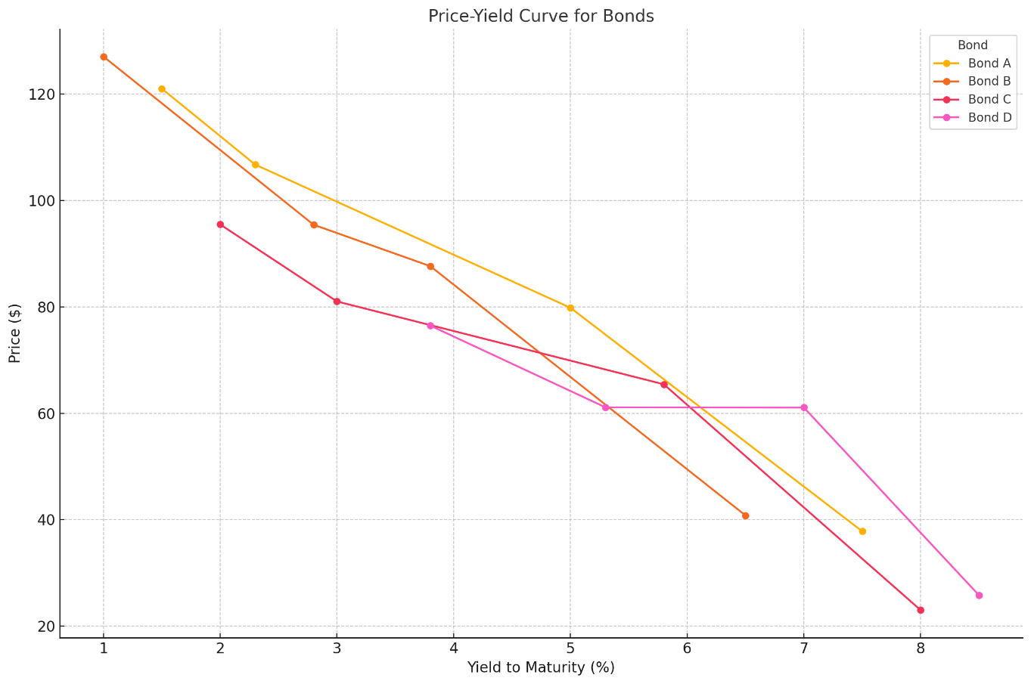
- The chart above displays the price-yield curves for Bonds A, B, C, and D. Each curve illustrates the inverse relationship between the bond's price and its yield to maturity (YTM).
- As the YTM increases, the bond price decreases, reflecting the reduced present value of the bond's cash flows.
- Bonds with longer maturities (e.g., Bond D) or lower coupon rates (e.g., Bond C) are more sensitive to yield changes. This is evident from the steeper slope of their price-yield curves.
- Bonds with shorter maturities or higher coupon rates (e.g., Bonds A and B) are less sensitive, resulting in flatter price-yield curves.

Yield and Maturity Relationship -

- This bar chart highlights the relationship between Yield to Maturity (YTM) and Modified Duration for different bonds.
- Bond A: Moderate YTM (5.30%) and duration (7.57) make it suitable for investors seeking a balance between return and sensitivity to rate changes.
- Bond B: Slightly lower YTM (4.91%) and moderate duration (7.87) indicate it is similar to Bond A but with slightly lower return potential.
- Bond C: Low YTM (4.49%) and the lowest duration (5.66) make it ideal for conservative investors who prioritize stability over returns.
- Bond D: High YTM (5.23%) and the highest duration (18.33) indicate significant sensitivity to rate changes, making it suitable for aggressive investors expecting declining interest rates.

Tangent Line and Convexity:
The tangent line on the price-yield curve provides a linear approximation of the bond's price sensitivity for small changes in yield. However, due to the bond's convexity, this linear approximation becomes less accurate for larger yield changes.
Bond A (Current YTM: 5.26%, Modified Duration: 7.57, Current Price: 101.43)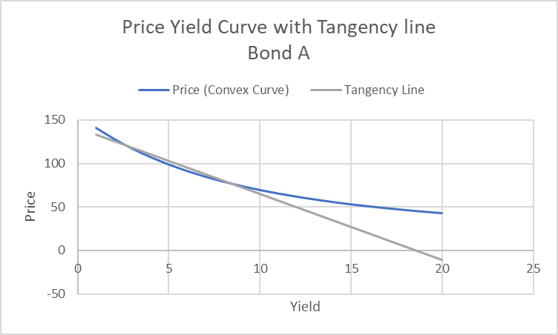

Bond B (Current YTM: 4.90%, Modified Duration: 7.87, Current Price: 100.78)
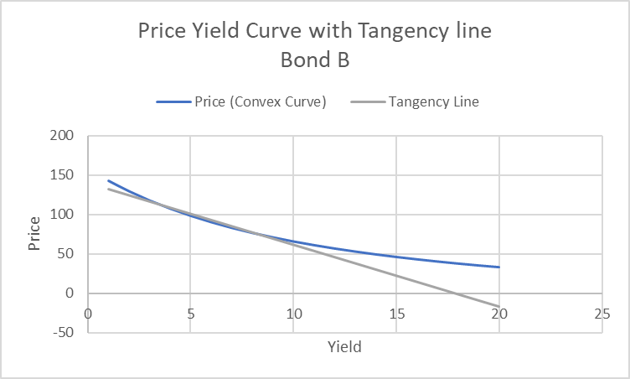

Bond C (Current YTM: 4.49%, Modified Duration: 5.66, Current Price: 94.58)
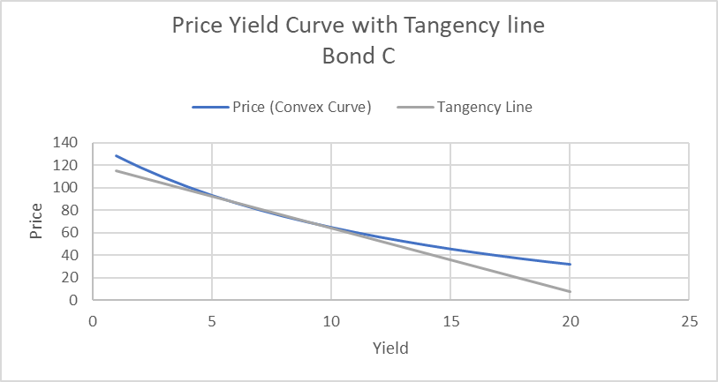

Bond D (Current YTM: 5.59%, Modified Duration: 18.33, Current Price: 85.40)
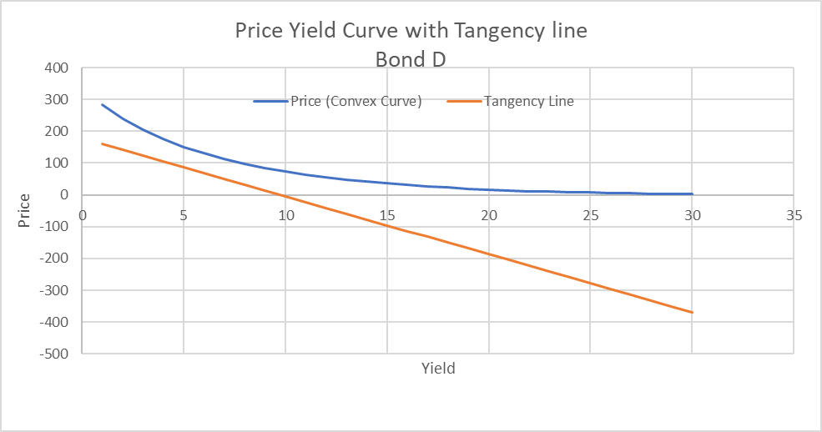
- Bond D exhibits the highest sensitivity to interest rate changes, as evidenced by its steep price-yield curve and the highest modified duration (18.33). Additionally, its high convexity (428.99) suggests that its price fluctuations are more pronounced for larger changes in interest rates.
- Bonds A and B display moderate sensitivity, with modified durations of 7.57 and 7.87, respectively. Their convexities are also moderate, indicating a less dramatic response to significant interest rate changes.
- Bond C shows the lowest sensitivity, with the lowest modified duration (5.66) and convexity (110.35). Its price-yield curve is the least steep, indicating lower price volatility in response to interest rate movements

Conclusion:
- Investment Recommendation: Hold
Justification:
Bond Yields
Yield-to-Maturity (YTM):
- Bond A (5.26%) and Bond B (4.9%): Offer competitive returns for their maturities, appealing for stable income generation.
- Bond C (4.49%): The lowest YTM, less attractive in a rising interest rate environment.
- Bond D (5.59%): The highest YTM, reflecting potential higher returns but significant sensitivity to interest rate fluctuations.
Yield-to-Call (YTC):
- Callable bonds A (5.25%) and B (4.8%) have slightly lower returns if called, limiting long-term income potential, especially in a declining interest rate environment.

Duration and Interest Rate Sensitivity
- Bond D (18.81 duration): Highly sensitive to interest rate changes, making it risky in a volatile rate environment but attractive if rates are expected to decrease.
- Bond C (5.78 duration): Least sensitive, ideal for investors seeking stability.
- Bond A (7.77 duration) and Bond B (8.06 duration): Offer balanced exposure to rate changes, suitable for moderate-risk investors.

Company Risk
- Credit Ratings: Coca-Cola holds investment-grade ratings (A1 by Moody’s, A+ by S&P), signalling strong financial health and low default risk.
- Debt Profile: Debt-to-equity ratio of 2.03 indicates high leverage, but strong interest coverage (10.4x EBIT/interest) and consistent cash flow mitigate risks.
- Profitability: High operating margins (21.2%) and stable revenue growth support confidence in Coca-Cola’s ability to meet bond obligations.

Default Risk
- Coca-Cola’s consistent operating cash flow, robust credit ratings, and diversified global business model significantly reduce default risk. Investment-grade ratings reinforce its reliability as a bond issuer.

Interest Rate Environment
- Current Scenario: Elevated interest rates have suppressed bond prices. Longer-duration bonds like D are more sensitive to further increases, while shorter-duration bonds offer better price stability.
- Future Projections: Potential stabilization or gradual rate cuts in the future may support price recovery, especially for long-duration bonds like D.

Market Comparison
- Coca-Cola bonds' yields are competitive within the investment-grade market segment, but they do not offer substantial advantages over peers. Bond D stands out for aggressive investors due to its high YTM and significant price discount.

Summary:
A Hold recommendation reflects Coca-Cola’s bonds’ robust credit profile, moderate yields, and balanced risk-return profile. Specifically:
- Bond A and Bond B: Offer moderate yields and durations, ideal for steady income with controlled interest rate risk.
- Bond C: Suitable for conservative investors prioritizing price stability over returns.
- Bond D: Suitable only for aggressive investors anticipating declining interest rates. Its high duration and YTM make it risky in the current environment.
Overall, the bonds are attractive for holding, but not for new purchases unless there is a clear shift in interest rate or credit market dynamics.

The Four Cs of Bond Analysis for Coca Cola:
To analyze Coca-Cola's bonds using the "Four Cs of Credit Analysis" framework, we can evaluate the following factors:
1) Character:
Management Quality and Strategy: Coca-Cola's management team is highly experienced and has a history of responsible financial management. Their strategic plans focus on sustainable growth and innovation.
Dividend Policy: Coca-Cola's dividend policy is sustainable, leaving ample room for debt repayment.
Financial Reporting: Coca-Cola's financial reports and disclosures are transparent and easy to understand, with no red flags.
2) Capacity:
Leverage Ratios: Coca-Cola's debt-to-equity ratio is 2.03, which is slightly above the industry average of 1.8. This indicates moderate reliance on debt for growth and strategic initiatives.
Coverage Ratios: Coca-Cola's EBITDA-to-interest coverage ratio is 12.0x, demonstrating a strong ability to cover interest payments. Their EBIT-to-interest coverage ratio is 10.4x, also showcasing robust operational performance.
Profitability and Cash Flow: Coca-Cola exhibits strong profitability margins (21.2% GAAP operating margin) and generates significant cash flow, enabling them to cover operating expenses, capital expenditures, and debt payments.
3) Collateral:
Asset Base: Although Coca-Cola's bonds are unsecured, they have a valuable brand, property, and other assets that could indirectly support their debt.
Credit Ratings: Coca-Cola maintains investment-grade credit ratings (A1 from Moody's and A+ from S&P), indicating low default risk.

4) Conditions:
Industry Outlook: The beverage industry is experiencing growth in developing nations and the functional beverage sector. However, there are challenges from health trends and environmental concerns.
Economic Conditions: Coca-Cola's business could be impacted by interest rates, inflation, and economic growth.
Competition: Coca-Cola faces strong competition from PepsiCo, Nestlé, and Red Bull. However, their market leadership and diverse portfolio provide resilience.

